University of Louisville

College of Business

CIS 300: Computer Information Systems

|  |  |
| --- | --- |
| Dr. Matt Thatcher  Associate Professor  CoB Room 304 (office)  (502) 852-4780 (phone)  (502) 852-4875 (fax)  [**matt.thatcher@louisville.edu**](mailto:matt.thatcher@louisville.edu) | Course Website: [**https://blackboard.louisville.edu/webapps/login**](https://blackboard.louisville.edu/webapps/login%20) |
| Office Hours: MW 12:30pm – 1:30pm, or by appointment |
| Free Tutoring: REACH [**http://www.reach.louisville.edu/tutoring/computer/**](http://www.reach.louisville.edu/tutoring/computer/) |

Homework Assignment 1 (Excel)

Team Member Names: (Ellis, Jake|

(last name, first name) |

(last name, first name) |

CIS300: -01 |

Date: 1/19/2010 |

The purpose of this homework assignment is to assess your knowledge, understanding, and application of logical functions used in some of the more common spreadsheet software products, specifically IF statements, Nested IFs, as well as Boolean operands (AND, OR, NOT). Students should not use Excel to solve the following problems. Instead, your responses should be entered directly into the respective answer fields provided on the next page.

First, update the identification information in the shaded area above. Be sure to include the first and last name of each team member and the Section of CIS 300 that the team attends.

If you do not have Microsoft Office installed on your PC, you should consider purchasing a copy of this software suite from the UofL ITStore at a significant discount available to all students. If you are unable to do so for financial reasons, then you will need to download a 60-day trial copy from the vendor using the respective URL in the External Links area of Blackboard. Microsoft Office should be installed on all UofL computers. These PCs are available for all students to use in various computer centers and labs located throughout the University. Future Assignments will require that you use Excel, Access, and/or Word.

Be sure to check your answers against the solution set provided in Blackboard. It is not necessary to include more than one answer for each problem, although you are certainly encouraged to attempt to do so. You should use Excel to validate a specific answer only if absolutely necessary.

Please feel free to email the professor should you have any questions or issues concerning to this assignment.**Part 1:** Use the following image – referencing cells A4 to D8 (A4:D8) to solve the formulas given below for (a) through (k). Write your answers in the shaded areas below. **Try not to use Excel to solve these!**

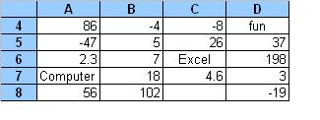

(a) =IF(B4<D6,C5,A6) 26 |

(b) =IF(SUM(B4:B7)>=D5,A4,"Nope") Nope |

(c) =B5<A5 False |

(d) =(2*B6)>(C4+10) True |

(e) =IF(C4=26,IF(B5=19,2,4),IF(A8=56,6,8)) 4 |

(f) =AND(A8>B7,B6<D6) True |

(g) =IF(AND(D8<10,D8>20),A4,B7) 18 |

(h) =IF(OR(D8>10,D8<20),A4,B7) 86 |

(i) =IF(AND(OR(B6=7,C6="Excel"),NOT(B7>20)),44,33)

44 |

(j) =IF(OR(NOT(B5<6),D7>3),A7,IF(AND(C4=2*B4,D8>D7),C6,D4))

Fun |

(k) =IF(D5="D5",D5,"D5") D5 |

**Part 2:** What is the result of evaluating each of the following formulas? Provide your answers in the shaded areas adjacent to each question below. **Try not to use Excel to solve these!**

(a) =IF(AND(6>3,3>8,2>7),"Access","Excel") EXCEL |

(b) =IF(OR(1>3,8>2),"yes",5) yes |

(c) =IF(OR(AND(4>2,2>3),OR(8>7,4>5)),7,9) 9 |

(d) =IF(AND(6>3,4>7),IF(5>2,8,7),IF(5>3,3,9)) 3 |

(e) =IF(SUM(3,5,7)=MAX(11,19,15),23,IF(NOT(OR(4=5,MIN(4,1,3)=1)),IF(4>2,6,7),9))

9 |

**Part 3:** The ages of John, Juan, and Wan are in cells D4, D5, and D6 respectively. Provide the Excel equivalents of the following conditions in the shaded areas below. Each part is independent of any of the others. **Note:** For some of the statements below, there may be various formulas that can be used to solve the condition; however, you need only to provide one of them. **Try not to use Excel to solve these!**

(a) Juan is at least 18 years old.

= (D5>=18) |

(b) Wan is not more than 55.

= (D6<=55) |

(c) John is at most 23.

=(D4<=23) |

(d) Both Wan and John are under 25.

= AND(D4<25,D6<25) |

(e) John is between 19 and 23, inclusive.

=AND(D4<=23,D4>=19) |

(f) At least one person, of the three, is over 21.

= OR(D4>21,D5>21,D6>21) |

(g) No one is over 65.

= AND(D4<=65,D5<=65,D6<=65) |

(h) Juan and Wan are under 22 but John isn't.

= AND(D4>=22,D5<22,D6<22) |

**Part 4:** You have been asked to create a worksheet to select stocks for clients of an investment firm. We have gathered some of the relevant data in the following worksheet (see image below). The P/E Ratio is the closing price per share divided by this year’s earnings per share (EPS).

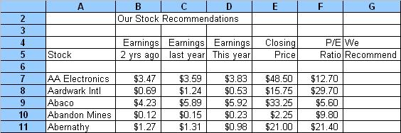

What Excel formula should be placed into cell G7 and then be copied down for each of the following recommendations? Each of the cells in column G should contain a “Buy”, “Sell” or “Hold” as text, unless no specific recommendation is made, in which case the cell should appear as a blank field (use a null text string). Each part is independent of any of the others. Provide Excel formulas in the shaded areas below that will solve the problem statement. There may be multiple formulas to satisfy a particular problem statement; however, you need only provide a single solution. **Try not to use Excel to solve these!**

(a) Buy if the P/E Ratio is below 10.

=IF(F7<10,”Buy”,””) |

(b) Buy if the earnings have increased. Sell if the earnings have decreased.

=IF(C7<D7,”Buy”,”Sell”) |

(c) Buy if the earnings have increased for each of the two years and the P/E Ratio is below 10.

Sell if the earnings have decreased both years.

=IF(AND(B7<C7,C7<D7,F7<10),”BUY”,IF(AND(B7>C7,C7>D7)”SELL”,””)) |

(d) Buy if this year's earnings are up over 20% from last year and this year's earnings are up over

30% from 2 years ago or if the P/E ratio is below 8. Sell if this year's earnings are down

over 20% from last year or if the P/E ratio is above 20. Otherwise, hold the stock.

=IF(OR(AND((C7*1.2%)<D7),(B7*1.3%)<D7,F7<8),”BUY”,IF(OR((C7*.8)>D7,F7>20),”SELL”,”HOLD”)) |

**Part 5:** The following Excel worksheet shows the weekly salary for some of the employees of the Begone Tomorrow Company. Each part is independent of any of the others. Provide Excel formulas in the shaded areas below that will solve the problem statement. Again, there may be multiple formulas to satisfy a particular problem statement, however, you need only provide a single solution. **Try not to use Excel to solve these!**

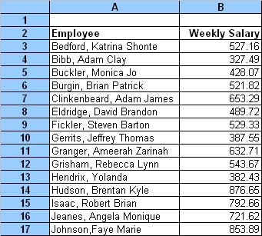

1. Calculate the minimum weekly salary of all employees. =MIN(B3:B17) |
2. Calculate the maximum weekly salary of all employees. =MAX(B3:B17) |
3. Calculate the total weekly salary of all employees. =SUM(B3:B17) |
4. Calculate the total weekly salary of all employees, but

round the result to the nearest dollar. =ROUND(SUM(B3:B17),0) |

**Part 6:** Employees of Acme Services are rated on three job performance dimensions – Effectiveness, Professionalism, and Quality. Scores are assigned from 1 to 100 for each of these three factors.

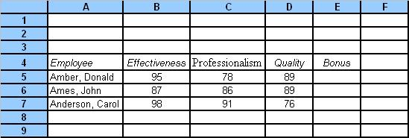

Provide a formula that will be entered in Cell E5 and will then be copied down for all other employees. Each employee’s bonus depends exclusively on that employee’s ratings. Each part is independent of any of the others. Provide Excel formulas in the shaded areas below that will solve the problem statement. Again, there may be multiple formulas to satisfy a particular problem statement, however, you need only provide a single solution. **Try not to use Excel to solve these!**

1. If the rating on Quality is above 90 then the person receives a bonus of $10,000. Otherwise, the person does not receive any bonus (zero dollars).

=IF(D5>90,$10,000,$0) |

1. If the rating on Quality is less than 90 and the rating on Professionalism is above 85, then the person receives a bonus of $7,000. Otherwise, the person does not get a bonus (zero dollars).

=IF(AND(D5<90,C5>85)$7000,$0) |

1. If the rating on Effectiveness is greater than 85 and the rating on Professionalism is above 85, then the person receives a bonus of $6,000. Otherwise, no bonus (zero dollars) is awarded.

=IF(AND(B5>85,C5>85)$6000,$0) |

1. If at least two of the ratings are above 90, the person receives a $10,000 bonus. Otherwise, no bonus (zero dollars) is awarded.

= IF(OR(AND(B5>90,C5>90),AND(B5>90,D5>90),AND(C5>90,D5>90)),10000,0) |

1. If all three of the ratings are above 80 and within 5 points of each other, then the employee receives a $5,000 bonus. Otherwise, no bonus (zero dollars) is awarded.

= IF(AND(B5>80,C5>80,D5>80,MAX(B5:D5)-MIN(B5:D5<=5),5000,0) |

**Part 7:** Judson Ford Realty uses an excel spreadsheet to keep track of October Sales. Answer the following questions based on the following spreadsheet. **Try not to use Excel to solve these!**

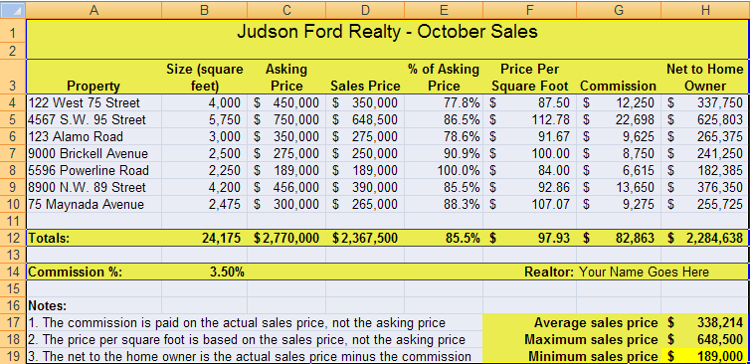

Notes: 1. The commission is paid on the actual sales price, not the asking price.

2. The price per square foot is based on the sales price, not the asking price.

3. The net to the home owner is the actual sales price minus the commission.

a) To calculate the percentage of the asking price, divide the sales price by the asking price. Write the formula that belongs in cell E4.

=D4/C4 |

b) To calculate the price per square foot, divide the sales price by the number of square feet. Write the formula that belongs in cell F4.

=D4/B4 |

c) To calculate the realtor’s commission, multiply the commission percentage times the sales price. Write the formula that belongs in cell G4.

=$B$4*D4 |

d) To calculate the net to the homeowner, subtract the commission from the sales price. Write the formula that belongs in cell H4.

=D4-G4 |

e) Compute the agency totals. Write the formula that belongs in cell B12.

Size (square feet) total: =SUM(B4:B10) |

f) Compute the agency statistics. Write the formulas that belong in cells H17, H18, H19.

Average Sales Price (H17): =AVERAGE(D4:D10) |

Maximum Sales Price (H18): =MAX(D4:D10) |

Minimum Sales Price (H19): =MIN(D4:D10) |

**Part 8:** The following table displays a hypothetical budget for a nine month academic year. **Try not to use Excel to solve these!**

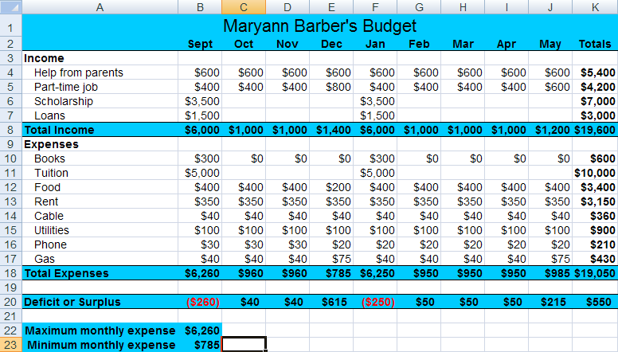

(a) Write the formula that belongs in the cell K8:

=SUM(K4:K7) |

(b) Write the formula that belongs in the cell K18:

= SUM(K10:K17) |

(c) Write the formula that belongs in the cell K20:

=K8-K18 |

(d) Write the formula that belongs in the cell B22:

=MAX(B18:J18) |

(e) Write the formula that belongs in the cell B23:

=MIN(B18:J18) |